

**COMPLIANCE MANUAL**

PREFACE

It is with great pleasure and a sense of accomplishment that this Compliance Manual is introduced that serves as a comprehensive guide for administration and management of EPFO’s Compliance functions at the field level.

The Compliance Division, through its field functionaries strives to secure compliance of the provisions of the EPF & MP Act, 1952 to extend social security to the intended beneficiaries. In order to do so, various instructions have been issued from time to time which guide the officers and officials entrusted with the compliance function. The Compliance manual, in your hand, not only consolidates statutory provisions, Head Office instructions, and court interpretations at one place in ready- to -refer form but also offers an evolutionary perspective on compliance and addresses emerging challenges in the evolved landscape.

By providing a standardized and comprehensive reference document, the aim is to maintain uniformity, transparency, objectivity and fairness in a manner that fosters trust and excellence. Roles and responsibilities have been clearly demarcated.

It is expected that this Compliance Manual shall serve as a valuable resource in your journey to ensure a secure and prosperous future for all the EPF beneficiaries across the nation.

**Compliance Division**

**Employees’ Provident Fund Organization Head Office, New Delhi**

**Date: 5th February, 2024**

ACKNOWLEDGEMENT

The drafting, review and design of Compliance Manual would not have been possible without the tremendous efforts by all officers of the division. At the outset we would like to thank our CPFC, Ms. Neelam Shami Rao, IAS for her continuous guidance and motivation without which the Manual would not have seen the light of the day.

The Compliance Manual has been co-authored by Shri Rajesh Kumar Sinha, Regional Provident Fund Commissioner – I, Shri Akash Verma, Regional Provident Fund Commissioner – II and Shri Abhishek Kumar Mishra, Regional Provident Fund Commissioner – II.

The team has worked under the guidance of Shri S.K. Aggarwal, Additional Central Provident Fund Commissioner (HQ) and Shri P. Veerabhadra Swamy, Additional Central Provident Fund Commissioner.

Thanks are due to Shri Navendu Rai, Regional Provident Fund Commissioner – I, Shri Siddharth Singh, Regional Provident Fund Commissioner – I and Ms Pooja Singh, Regional Provident Fund Commissioner – I for providing valuable inputs from time to time.

Last but not the least, thanks are due to Shri Raunak N Chahande, Shri Santosh Kisku and Shri Devendra Kumar, ASOs in the Compliance Division who have meticulously compiled and catalogued the notifications and circulars. The manual has also been peer reviewed by officers of the field.

**Compliance Division**

**Employees’ Provident Fund Organization Head Office, New Delhi**

**Date: 5th February, 2024**

Table of Contents

PART A : CHAPTERS 1

1. Applicability 5
   1. Application of the EPF & MP Act, 1952 5
      1. Mandatory Application 5
      2. Voluntary Application 5
      3. Reduction in Strength 6
      4. Clubbing 7
   2. Exemption from the Act 7
   3. Schedule of Industries/Classes of Establishments 10
      1. Coverage of Establishments 11
      2. Registration 12
      3. Notification of Voluntary Coverages u/s 1(4) 14
2. Inquiries u/s 7A, 7B & 7C of the Act 17
   1. Introduction 17
   2. Officers and their Powers 19
   3. Procedure of Initiation and Conduct of Inquiry 24
      1. Initiation 24
      2. Issue of Summons 27
      3. Conduct of Inquiry 28
   4. Dos & Don’ts of Inquiries 31
   5. Jurisdiction of Officers (Administrative Directions) 33
   6. Ex-parte Order 34
   7. Review u/s 7B 35
   8. Determination of Escaped Amount u/s 7C 39
   9. Handling of Cases remanded back by Courts 39
   10. Timeline 40
   11. Administrative scrutiny of Orders 41
   12. Indicative Structure of the order u/s 7A 42
3. Levy of Damages u/s 14B 49
   1. Rule Provisions – Acts & Schemes 49
   2. Initiation of Proceedings 52
   3. Initiation & Conduct of Proceedings u/s 14B 56
   4. Timeline 59
   5. Knocking off of Auto Calculated Damages & Interest 60
   6. Penal Damages in Respect of Exempted Establishments 61
   7. Waiver of Damages 62
4. Resolution of Membership Doubts u/p 26B of the EPF Scheme, u/p 8 Of the EPS 67
   1. Introduction 67
   2. Basic Premises 68
   3. Background 68
   4. Trigger Points for Requirement of Proceeding u/p 26B Of EPF Scheme/ 8 Of EPS 69
   5. Case of Student-Trainees 70
   6. Procedure for Initiation and Conduct of Proceeding u/p 26B 71
5. Penal Provisions 75
   1. Introduction 75
   2. Prosecution 79
      1. Importance of Form 5A 79
      2. Procedure to Follow 79
      3. Misjoinder of Charges 81
      4. Persons liable to be impleaded in the Complaint 83
      5. Withdrawal of Prosecution 83
      6. Compensation u/s 357 of CrPC, 1973 85
      7. Limitation for Prosecution - Section 468 of CrPC, 1973 86
      8. Transfer of complainant 87
      9. Criminal Breach of Trust 88
      10. Proceedings under provisions contained in section 110 of the Code of CrPC, 1973 89
6. Handling of Compliance Issues in Insolvency & Bankruptcy Cases 93
   1. Introduction 93
   2. Action for Assessment and Recovery of Dues Prior to Commencement of CIRP 94
   3. Initiation of CIRP and Follow-Up Action by EPFO 96
   4. Procedure to be followed when CIRP has started 97
   5. Procedure for Multi-Location Establishments 98
   6. Admissibility of Appealed/Litigated Dues 99
   7. Remedies – Procedure for Appeals 99
   8. Post CIRP Issues 99
   9. Relevant Case Laws 100
7. Establishment Master Updation 105
   1. Introduction 105
   2. Verification of Status through GST Portal 106
   3. Establishments Declaring Closure on Nudging 107
   4. Marking Closure in Case of Establishments Covered U/S 1(4) 107
   5. Marking Closure in Case of Establishments Covered U/S 1(3)/2A 108
   6. List of Defaulting Establishments 109

PART B : STANDARD OPERATING PROCEDURES(SOPs), FORMS & TEMPLATES 111

PART C : NOTIFICATIONS 211

List of Industries 213

Classes of Establishments 293

PART D : CIRCULARS 382

vi

PART A : CHAPTERS

CHAPTER 1 : APPLICABILITY



# Applicability

## Application of the EPF & MP Act, 1952

The Act extends to the whole of India.

### Mandatory Application

* + - 1. To every establishment, which is a factory, engaged in any industry specified in Schedule-I and in which twenty or more persons are employed [Sec 1(3)(a)].
      2. To any other establishment employing twenty or more persons or class of such establishments which the Central Government may, by notification in the Official Gazette, specify in this behalf [Sec 1(3)(b)].
      3. Provided that the Central Government may, after giving not less than two months’ notice of its intention so to do, by notification in the Official Gazette, apply the provisions of this Act to any establishment employing such number of persons less than twenty as may be specified in the notification. In case of ‘Cinema Theatres,’ the Central Government has fixed the required employee strength at five (5) for the purpose of coverage under the Act. The Central Government has also applied the EPF & MP Act, 1952 to all the establishments, employing ten or more persons and covered under the provisions of the erstwhile the Jammu and Kashmir Employees’ Provident Funds and Miscellaneous Provisions Act, as it stood before its repeal by the Jammu and Kashmir Reorganization Act, 2019, with effect from 1.1.2020.
      4. Mandatory application of the Act is, however, subject to the provisions contained in Section 16 which allows for exemption from the application of the Act itself.

### Voluntary Application

* + - 1. Notwithstanding anything contained in Sub-Section 3 of Section 1 or-Sub-Section 1 of Section 16,

where it appears to the Central Provident Fund Commissioner, whether on an application made to him/her in this behalf or otherwise, that the employer and the majority of employees in relation

to any establishment have agreed that the provisions of this Act should be made applicable to the establishment, the CPFC may, by notification in the Official Gazette, apply the provisions of this Act to that establishment on and from the date of such agreement or from any subsequent date specified in such agreement [Sec 1(4)].

* + - 1. Three scenarios may emerge here:

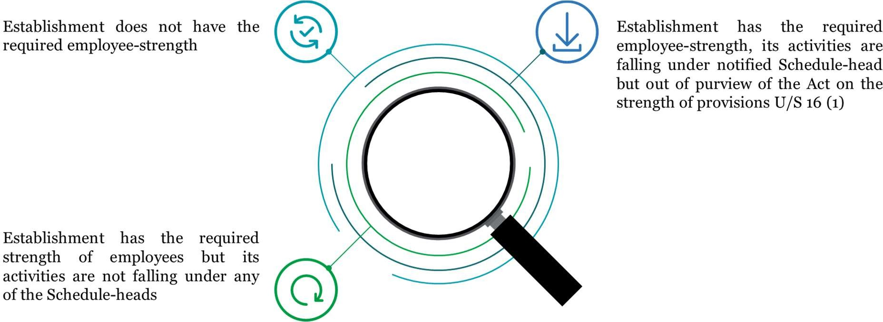

*Figure 1 : Scenarios for Establishments applying u/s 1(4)*

* + - 1. As can be observed, application from the employer is not an essential requirement; CPFC’s satisfaction of consent of employer and majority of employees is the essential condition. In case of voluntary coverages under section 1(4), application of the Act can only be from the date of agreement, or some subsequent date specified in the agreement. There cannot be any retrospective coverage under section 1(4). ‘Notification in Official Gazette’ is an essential requirement for application of the Act under section 1(4) cases. Till notification is issued, the establishment is technically free to withdraw its application.

### Reduction in Strength

It has also been made clear under Section 1(5) of the Act, that once an establishment is brought under the purview of the Act, it shall continue to be governed by the Act notwithstanding that the number of employees at any time falls below twenty (five in respect of Cinema Theatres).

### Clubbing

* + - 1. **Branches and departments of an establishment should be clubbed together for the purpose of determining the employment strength.**

In accordance with **Section 2A** of the Act, where an establishment consists of different departments or has branches, whether situated in the same place or different places, all such departments/branches should be treated as part and parcel of the main establishment for the purpose of application of the provisions of the Act.

* + - 1. **Coverage of establishments by virtue of having a Common Provident Fund with another establishment.**

Where immediately before the Act becomes applicable to an establishment, there is in existence a Provident Fund, which is common to the employees in that establishment (which is coverable) and employees in any other establishment (which is not coverable), the Central Government may, by notification in the Official Gazette, extend the Act to such establishment which is not otherwise coverable under the Act, in accordance with the provisions of Section 3 of the Act.

## Exemption from the Act

* + 1. The Act shall not apply to:

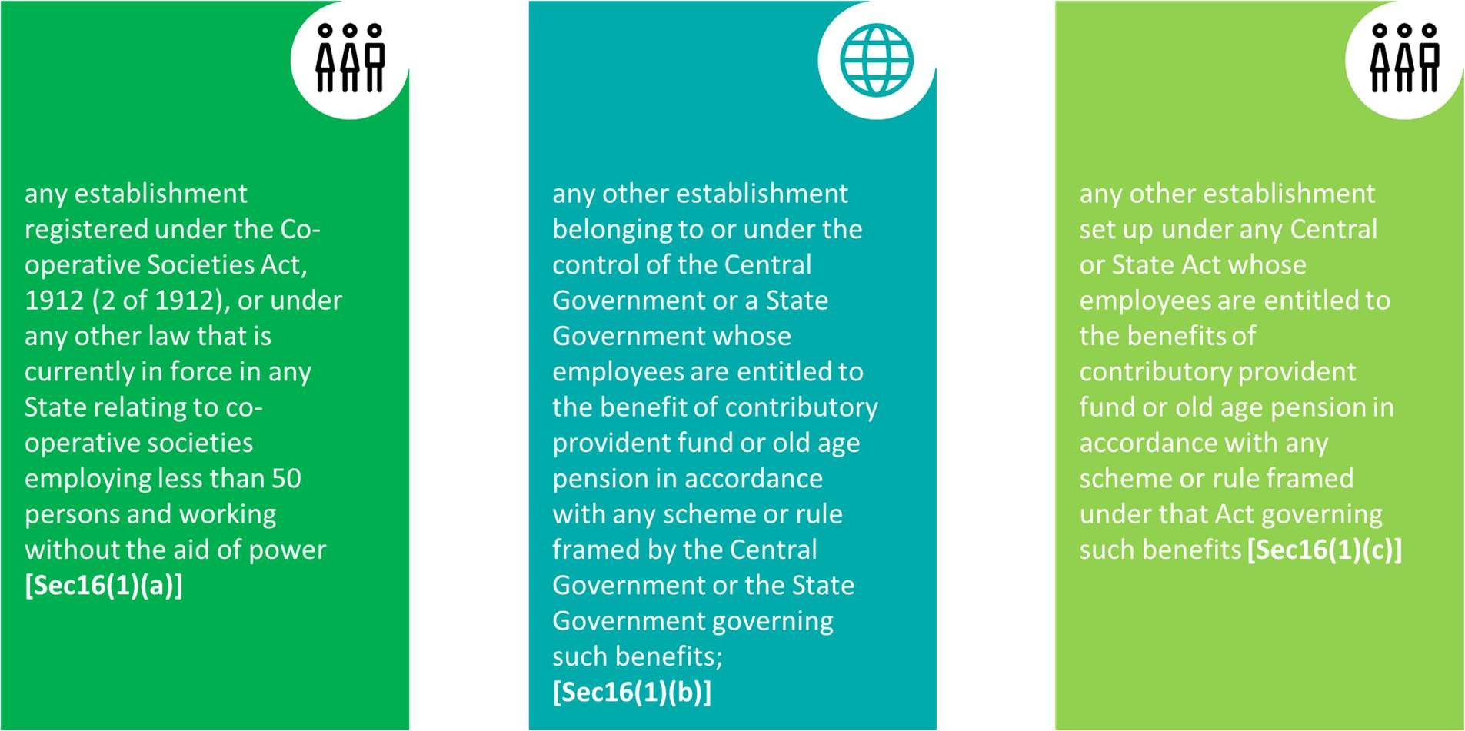

*Figure 2 : Exemption from the Act u/s 16(1)*

* + 1. Present clauses (b) and (c) have been inserted under section 16(1) vide Act 33 of 1988 w.e.f. 01.08.1988. By virtue of these provisions a large number of Departmental Undertaking and

Statutory Bodies have gone out of the purview of the Act. These exemptions are automatic and no notification or order to the effect is required to be issued. However, Government of India, Ministry of Labour vide its letter number S-35025/15/88-SS-II dated 06.01.1989 **(Part D/Circular No. 47)** has clarified the position as under in case of such establishments:

* + 1. The Central Government can also exempt any class of establishments from the Act by notification under section 16(2) of the Act for some specified period retrospectively or prospectively. Section 16(2) provides that if the Central Government is of the opinion that having regard to the financial position of any class of establishments or other circumstances of the case, it is necessary or expedient so to do, it may, by notification in the Official Gazette, and subject to such conditions, as may be specified in the notification, exempt, whether prospectively or respectively, that class of establishments from the operation of the Act for such period as may be specified in the notification.

Several notifications had been issued under section 16(2) from time to time exempting various class of establishments. The last notification under this section was issued on 14.5.2010 for establishments registered under the Societies Registration Act, 1860 (corresponding laws) exempting these, subject to conditions, for the period 1.4.2010 to 31.3.2015 [SO 1431 dated 14.5.2010]. There is no such notification in currency since 1.4.2015 issued under section 16(2) granting exemption to any class of establishments from operation of the Act.

While deciding date of applicability of the Act to establishments where the dates are going back before 03/2015, notifications issued under this section should also be kept in view.

* + 1. **Scope of Section 16(1)(b) of the Act**

Clause (b) of sub-section (1) of Section 16 provides for exemption to establishments belonging to or under the control of the Central Government or a State Government while clause (c) contemplates exemption to any other establishment set up under any Central, Provincial or State Act, subject to conditions specified therein.

Establishments set up under Central, Provincial or a State Act may be identified easily. However, the same cannot be said of establishments belonging to or under the control of the Central or a

State Government. There is no test/clue in the Act to identify establishments belonging to or under the control of the Central or a State Government.

The issue has been dealt with by the Hon’ble Supreme Court in ***Regional Provident Fund Commissioner v/s Sanatan Dharam Girls Secondary School and Ors [(2007) 1 SCC 268 : (2007) 1 SCC (L&S) 167 ].*** While clarifying the meaning of ‘belonging to or under the control of’, the Hon’ble Court has held as under:

“In our view, the two words used in the said section have different connotations. The words "belonging to" signifies ownership i.e., the Government owned institutions would be covered under the said part and the words "under the control of" signifies control other than ownership since ownership has already been covered under the words "belonging to". It must be also noted that the two words are separated by the word "OR" and therefore these two words refer to two mutually exclusive categories of institutions. While the institutions "belonging" to the Central or the State Government would imply the control of the State but the privately- owned institutions can be "under the control of" the Government in various ways.

…………………………………

The word "control" has not been defined under the EPF Act, 1952. However, this Court in Shamrao Vithal Coop. Bank Ltd. vs. Kasargode Panduranga Maliya, (1972) 4 SCC 600 at page 604 has cited with approval the meaning of the word "control" as it appears at page 442 of Words & Phrases Vol.9, Permanent Edition as under:

"The word "control" is synonymous with superintendence, management or authority to direct, restrict or regulate."

In the case of State of Mysore vs. Allum karibasappa, (1974) 2 SCC 498 at page 501, this Court defined the words "word control" as under:

"The word "control" suggests check, restraint or influence Control is intended to regulate and hold in check and restrain from action."

Hon’ble Supreme Court in ***Pawan Hans Limited and Ors vs Aviation Karmchari Sanghatana & Ors [AIR2020SC564]*** dealing with the same issue has observed as under:

“This Court in Regional Provident Fund Commissioner vs Sanatan Dharam Girls Secondary School laid down a twin test for an establishment to seek exemption from the provisions of the EPF Act, 1952.

The twin conditions are:

First, the establishment must be either “belonging to” or “under the control of” the Central or the State Government. The phrase “belonging to” would signify “ownership” of the Government, whereas the phrase “under the control of” would imply superintendence, management, or authority to direct, restrict or regulate.

Second, the employees of such an establishment should be entitled to the benefit of contributory provident fund or old age pension in accordance with any scheme or rule framed by the Central Government or the State Government governing such benefits.

If both tests are satisfied, an establishment can claim exemption/exclusion under Section 16(1)(b) of the EPF Act.

Applying the first test to the instant case, the Central Government has a 51% ownership in the Appellant-Company, while the balance 49% is owned by the ONGC, a Central Government PSU.

As per Section 2(45) of the Companies Act, 2013, a “Government Company” means any company in which not less than 51 % of the paid--up share capital is held by the Central Government. Since 51% of the shares of the Appellant¬-Company are owned by the Central Government, the first test is satisfied as the Appellant-¬Company can be termed as a Government Company under Section 2(45) of the Companies Act, 2013.”

## Schedule of Industries/Classes of Establishments

The Act is applicable to factories engaged in industries specified in Schedule-I of the Act and to establishments/classes of establishments notified by the Central Government. All notifications issued till date are contained in **Part – C** of the Manual.

### Coverage of Establishments

* + - 1. The Act comes into operation by its own vigour and discovery of the establishment by the department is no requirement for application of the Act to the establishment from the date of eligibility. Hon’ble Supreme Court has held so in ***Associated Industries (Pvt) Ltd vs Regional P F Commissioner, Kerala [1963(2) LLJ 652(SC-5M)]*** and several other judgements.
      2. The Field Offices should however ensure that all coverable establishments are brought under the purview of the Act promptly. For this purpose, data triangulation could be of great help. Till the time some arrangement for exchange of data is made centrally, information should be collected from relevant agencies such as ESIC, Factories Department, Labour Department, Chamber of Commerce, Trade Unions, MCA portal, UDAISE portal FSSAI and Railways portal etc by the Field Offices.
      3. The data collected from these agencies should be matched with the information of establishments already covered under the Act to gather information of eligible but uncovered establishments. This exercise may be conducted preferably on quarterly basis so that effective and timely action could be taken to extend the provisions of the Employees’ Provident Funds and Miscellaneous Provisions Act, 1952 to such establishments.
      4. As the establishments are expected to register themselves on their own, in case of establishments not registering on their own under the EPF & MP Act, 1952 despite being coverable under the Act, the RPFC/APFC-in-charge should take immediate steps to contact and persuade such establishments for registration through Shram Suvidha Portal. If any such establishment is still not coming forward for coverage under this Act on its own in spite of persuasion made by the office, permission from CAIU should be obtained and then the Enforcement Officer may be deputed to verify the position to bring the establishment under the ambit of the Act from the date of eligibility in order to ensure extension of social security benefits to the employees of such establishment.

### Registration

Depending on its type, an establishment can register under the Act using any of these online portals:

|  |  |  |
| --- | --- | --- |
| **Portal URL** | **Type of Establishment** | **Remarks** |
| MCA Portal  <http://www.mca.gov.in/> | All Companies | w.e.f. 15.02.2020 |
| Shram Suvidha Portal https://registration.shrams  uvidha.gov.in/user/login | Any other type of establishment |  |

* + - 1. Options are available for the employer to apply online under the following conditions:

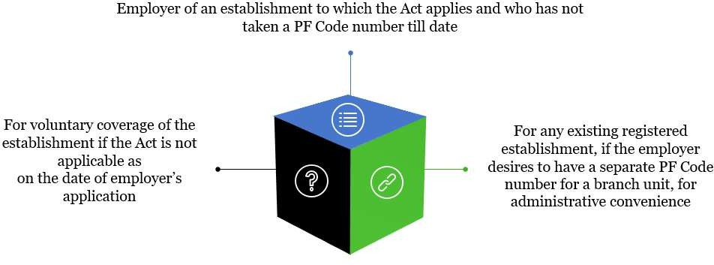

*Figure 3 : Options for Employers for Online Application*

* + - 1. While filling the form the employer has to upload documents related to the establishment as specified on the portal. The employer has to digitally approve the filled form.
      2. The code number allotment letter and documents uploaded by the Employer are available with field offices on FO interface. The same should be downloaded and scrutinized properly and promptly. If any specific document is found missing or is not readable, the same should be collected by the RO/DO from the establishment through email or otherwise.
      3. E-office compliance file of the establishment would be created with these documents downloaded from the FO interface which should be put up by the section to the Circle Officer for confirmation of receipt of the basic documents.

**FO-interface >>OLRE>>View Documents**

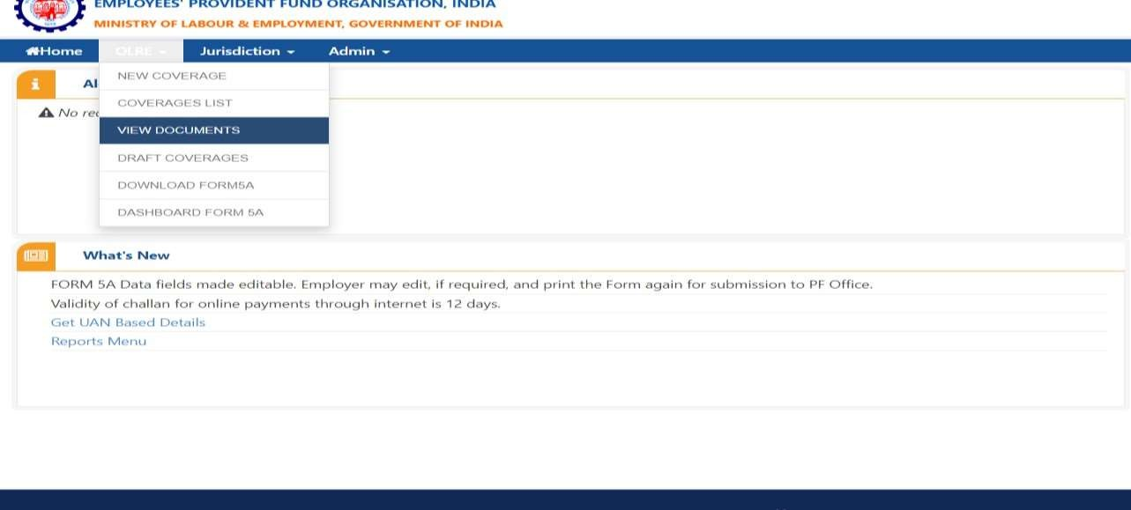

**The following details appear in the view document:**

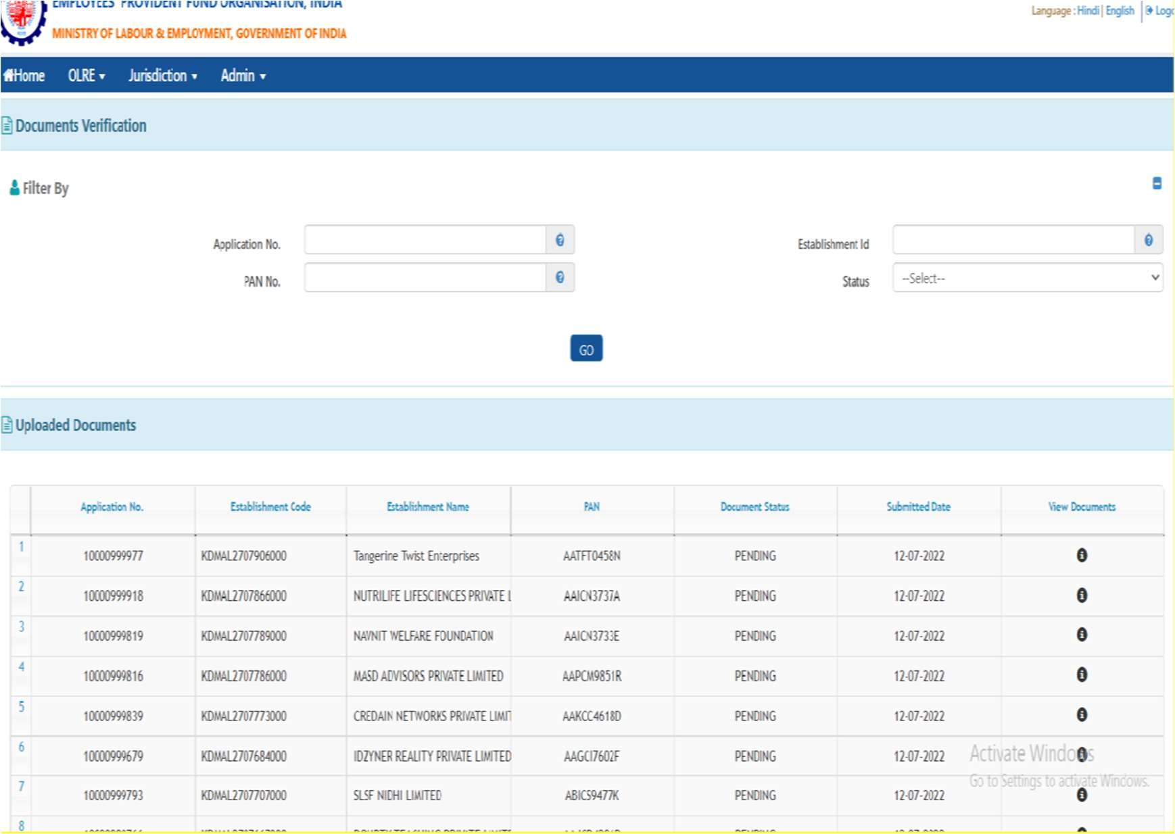

### Notification of Voluntary Coverages U/S 1(4)

* + - 1. All voluntary coverages obtained under section 1(4) should immediately be processed for notification in the Official Gazette as is the requirement under the section concerned.
      2. Section 1(4) needs satisfaction of CPFC, on an application made or otherwise, that the employer and the majority of employees have consented to make the provisions of Act applicable. Therefore, application of the employer and his consent along with consent of majority of employees should be collected and if contribution of even one month has been paid, the case should be processed for notification. Standard proforma for employees’ consent and employer’s application-cum-consent may be used by the employers. **(ST 1 & ST 2).**
      3. ZO concerned has to get the coverage notified in the official gazette once the same is approved by the CPFC. Therefore, the original documents need not be sent to HO. Only the information as required under Head Office circular number C-I/4(3)2016/AP-OR/1(4)/2709 dated 05.05.2017 **(ST 3)** should be forwarded to Head Office [ACC(HQ)/ACC of Compliance Division] for approval of CPFC by the ZO concerned through e-office. On communication of approval of CPFC, ACC Zone has to make arrangement for notification of such establishments in Official Gazette.

**\*\*\*CHAPTER END\*\*\***

CHAPTER 2 : INQUIRIES U/S 7A, 7B &

7C OF THE ACT



# Inquiries u/s 7A, 7B & 7C of the Act

## Introduction

The statutory mandate for inquiry under section 7A is two-fold:



* + 1. When the Employees’ Provident Funds and Miscellaneous Provisions Act, 1952 was framed in the year 1952, it did not provide for any forum for determination of dues. Hon’ble Courts had, however, held that the action to recover the amount due under the Act, by way of recovery proceedings, could be taken only after the determination of dues. Hence, section 7A was inserted in the Act, by the Amendment Act 28 of 1963 to remove the above lacuna in the Act, by providing a forum to determine the dues under the Act.
    2. When the Section 7A was inserted, the respective State Governments were empowered to recover dues. To simplify and rationalise the process, Section 7A was amended in the year 1973 empowering the Central Provident Fund Commissioner, Deputy Provident Fund Commissioner, Regional Provident Fund Commissioner to exercise the power under Section 7A. Though there was no specific provision in the Act to decide applicability disputes, in various court judgments it was held that the assessing authority should first decide the dispute of applicability, if such dispute was raised by the employer and then only determine the dues. **[D K Barua vs RPFC 1972 I LLJ 385 (Pat DB); Mahamaya Coconut vs RPFC 1972 II LLN 540 (Ori DB)]**
    3. By the Amendment, Act 33 of 1988, the power to conduct inquiry under Section 7A was extended to Additional Central Provident Fund Commissioners and Assistant Provident Fund Commissioners as well to speed up the assessment of dues and take timely action against defaulters. Provision was made expressly empowering officers exercising the powers under this section to decide the dispute relating to the applicability of the Act to an establishment, when such a dispute arose. The

amendment also provided for appeal against the orders of the adjudicating authority hitherto not available by inserting section 7-I.

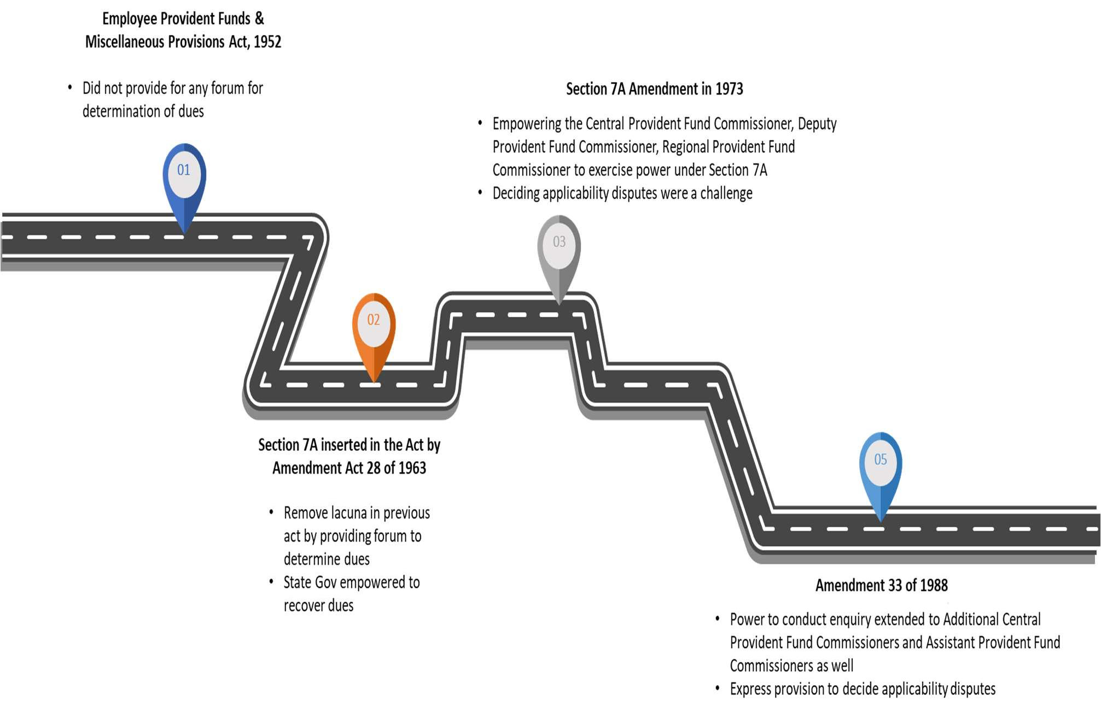

*Figure 4 : Developments over the years*

* + 1. Due care should be taken while initiating inquiries so that while rights of the employees under the Act are protected without any compromise, there is no undue hardship to the employer in the process as well. The authority clothed in the trappings of a Court under the Code of Civil procedure, is required to act judiciously, fairly, transparently, and equitably following the principles of natural justice. Hence, such inquiries are required to be initiated after establishing a prima-facie case of default / applicability dispute.
    2. The idea is to secure compliance first by handholding, persuasion & nudging before resorting to initiation of inquiry. However, though the attitudinal change of keeping the idea of Ease of Doing Business in view is expected, the idea of **‘compliance with no compromise’** should never be lost sight of.

## Officers and their Powers

* + 1. Section 7A (1) authorizes the Central Provident Fund Commissioner, Additional Central Provident Fund Commissioners, Deputy Provident Fund Commissioners, Regional Provident Fund Commissioners or Assistant Provident Fund Commissioners to decide disputes regarding applicability of the Act to an establishment and/ or to determine amount due from any employer under the provisions of the Act/Schemes by order. For the aforesaid purposes, such inquiry as deemed necessary may be conducted by the Commissioner deciding the applicability- dispute/determining amount due.
    2. Section 7A (3) provides that no such order shall be made unless the employer concerned is given reasonable opportunity of representing his case. Providing reasonable opportunity before passing an order is a requirement of the principle of natural justice. The two core concepts of the principle of natural justice are; *audi alteram partem* (hear the other side or no one should be condemned unheard) and nemo judex in causa sua (no one should be a judge in his own case).
    3. It is therefore essential legal requirement that reasonable opportunities of hearing be provided to the employer and the Central Board is represented by someone other than the officer conducting the inquiry.
    4. Section 7A (2) vests the officers conducting inquiry under section 7A (1) with the same powers as are vested in a court under the Code of Civil Procedure, 1908 for trying a suit in respect of the following matters, namely:
       1. Enforcing the attendance of any person or examining him/her on oath
       2. Requiring the discovery and production of documents
       3. Receiving evidence on affidavit
       4. Issuing commissions for the examination of witnesses
    5. Relevant sections dealing with the aforementioned subjects in the Code of Civil Procedure, 1908 are Sections 27 to 32 under the heading ‘Summons and Discovery’:

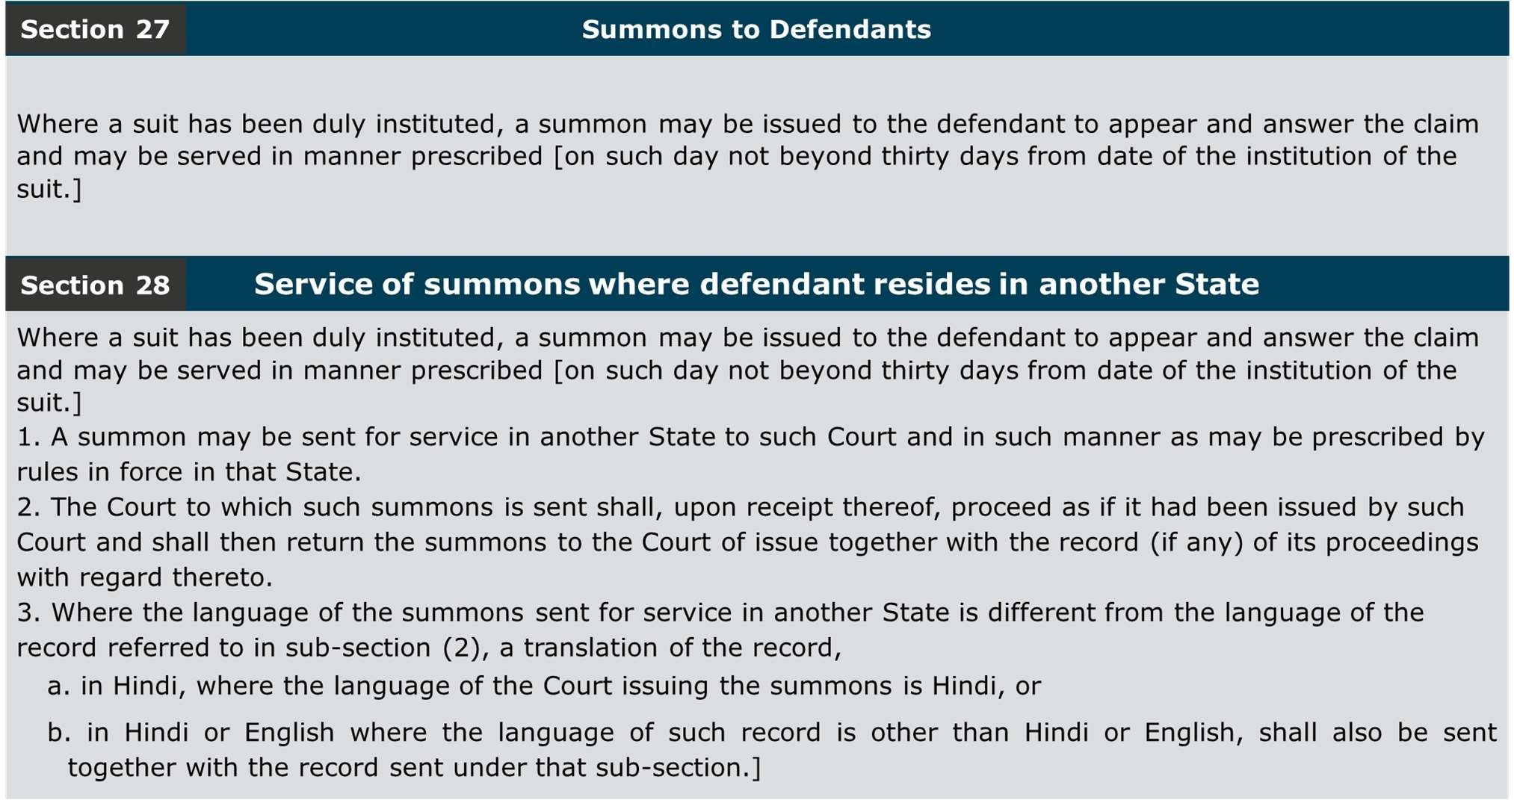

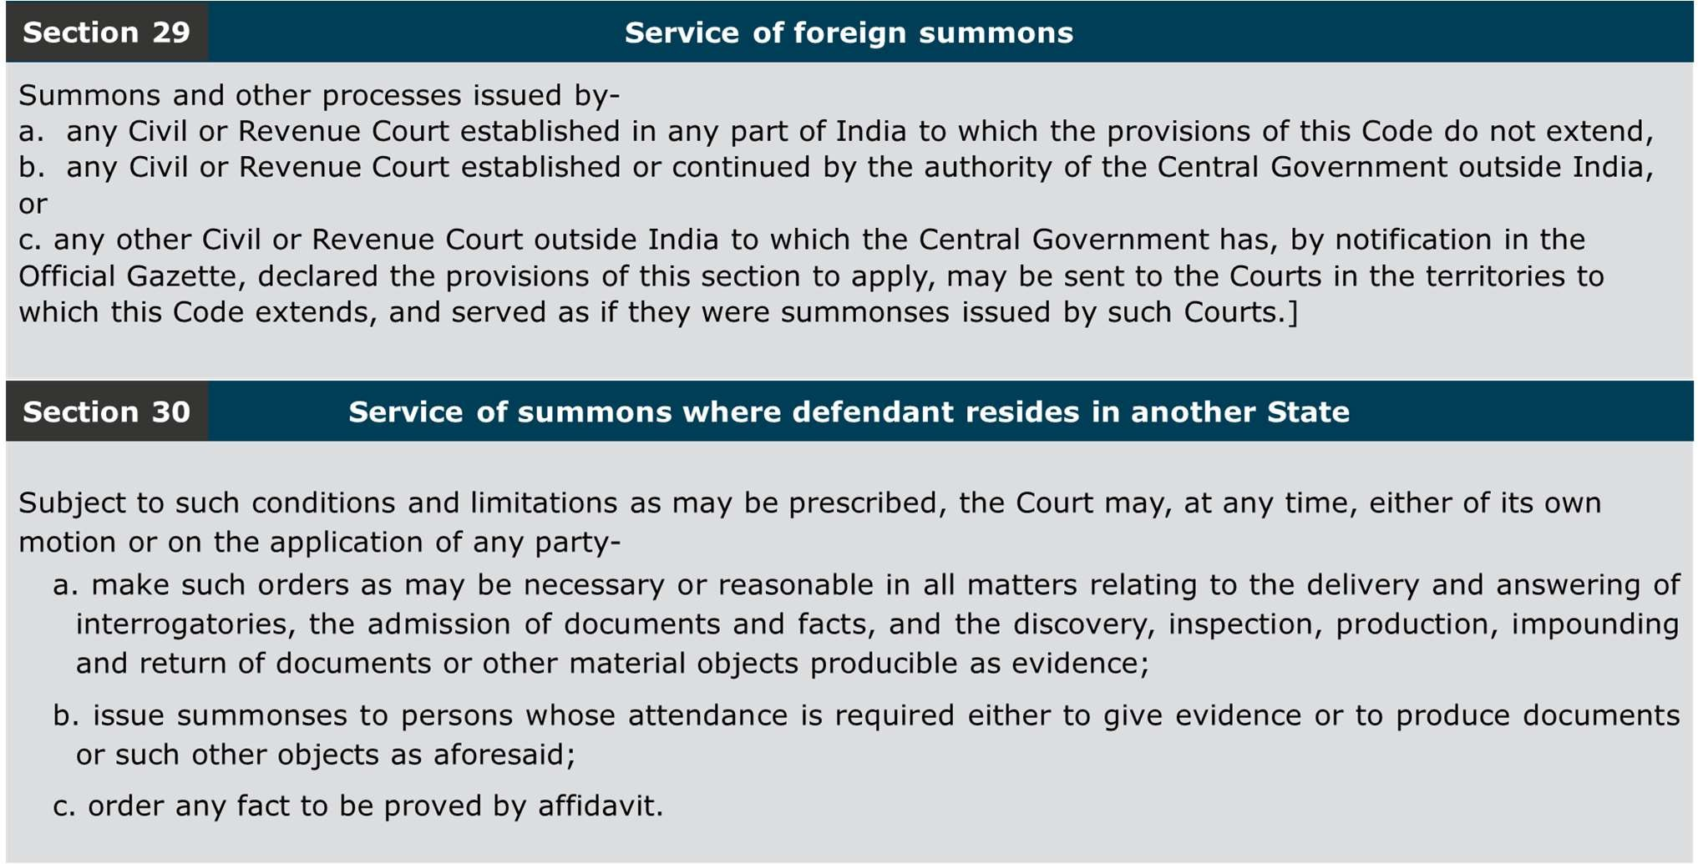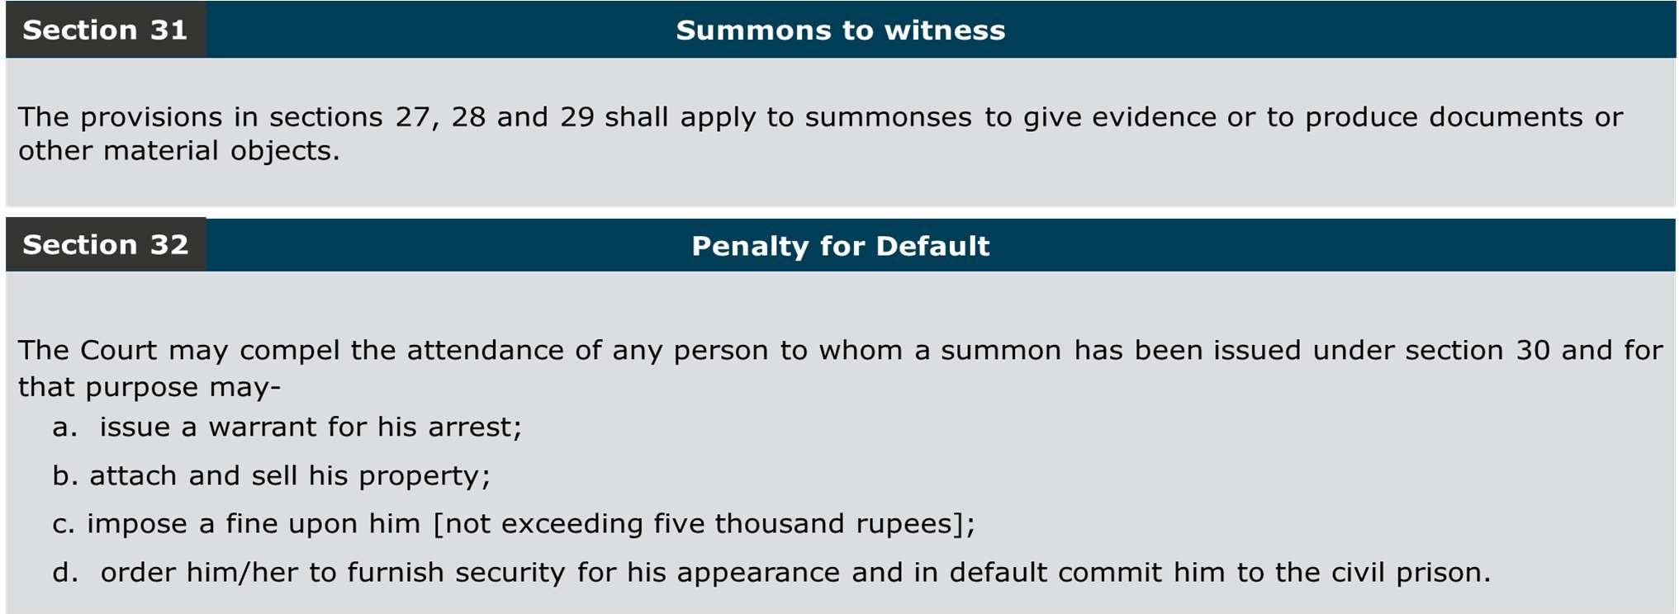

* + 1. At times, situations may be encountered during the proceedings where employer may refuse to cooperate ostensibly to prolong/delay the proceedings for various reasons and on the other hand, sufficient documents may not be on record to pass an ex parte order. In such situations, it is under section 30 of the Code of Civil Procedure, 1908 that show cause notices are issued during the proceedings against the recalcitrant employers who refuse or neglect to produce the required documents or part with any other information sought. Sample notice to the employer under section 30 of the CPC is at **ST 5.**
    2. At times witnesses are also to be called for taking their statements during the inquiry. Sample of summons to witness is at **ST 6.**
    3. Section 32 of the CPC prescribes the means through which attendance of a person to whom summons has been issued is compelled. The provisions are self-explanatory, yet instances have been noticed in which the officers conducting inquiries u/s 7A have issued orders to attach/freeze bank accounts of the establishments/personal accounts of the employers for alleged non- appearance in such inquiries. Such practices have attracted a lot of adverse observations from Constitutional Courts and other quarters; hence, must not be resorted to.
    4. In so far as the power to impose fines for non-appearance, by invocation of section 32 CPC is concerned, it may be noted that the power of a Civil Court, and consequently an officer exercising jurisdiction under section 7A, in imposing a pecuniary fine for wilful absence of a party summoned, is restricted to the amount of Rupees Five Thousand only by virtue of section 32 of the CPC.
    5. The power to attach and sell property for non-appearance is also subject to limitation prescribed in rule 10 of Order XVI of the CPC which circumscribes the power so available to the limit of fine imposable under rule 12. Alternatively stated, when the power to attach and sell property of the employer is sought to be exercised for non-appearance, the value of property so attached has to be within the quantum of fine that could be levied under the relevant provision.

**Note**: *It has been observed, in a number of cases, that the officers issue attachment orders without specifying any amount to the extent of which the attachment is intended to be made. It is important to note that the power to make attachments of unlimited value or to freeze operation of bank accounts is not relatable to any provision of the Act or Code of Civil Procedure. Such actions are evidently illegal and amount to blatant misuse of authority besides causing unwarranted harassment to the employers concerned.*

* + 1. In case the person to whom summons is issued for production of document or discovery of any document and he commits default in attendance, the 7A authority is empowered to issue warrant of arrest under section 32 of the Code of Civil Procedure, 1908. [**Devi Ahilya Bai Ghate Uccha Shiksha Samiti and another vs State of MP and ors-2007(1) LLJ 78- MP High Court-Gwalior Bench**]. Sample of warrant of arrest issued under section 32 of the CPC is at **ST 7.**
    2. However, the 7A authority cannot direct detention of a person in civil prison in case he fails to produce the records which he has been summoned to produce. The power under Order XVI Rule 18 of the Code of Civil Procedure, 1908 can be exercised by the court only for the purpose of ensuring the appearance of the person and not when he fails to produce any document or record which he has been summoned to produce. Clause (d) of Section 32 of the Civil Procedure Code is the only provision providing for detention of a person in civil prison and it states that the Court may compel the attendance of any person to whom summons have been issued under Section 30 and for that purpose may order him to furnish security for his appearance and in default commit him to civil prison. The expression "for that purpose" clearly indicates that the detention of a person in civil prison can be ordered by the Court only for the purpose of compelling his attendance. There is nothing in Section 32 of the Civil Procedure Code to indicate that the Court can detain a person to civil prison if he does not produce any record or documents which he has been summoned to produce. Similarly a reading of Rule 18 of Order XVI of the Civil Procedure Code shows that where any person arrested under a warrant is brought before the Court in custody and cannot, owing to the absence of parties or any of them, give the evidence or produce the document which he has been summoned to give or produce, the Court may require him to give reasonable bail or other security for his appearance at such time and place as it thinks fit, and, on such bail or security being given, may release him, and, in default of his giving such bail or

security, may order him to detain in civil prison. Thus, the power under Order XVI, Rule 18 of the

Civil Procedure Code can be exercised by the Court only for the purpose of ensuring the appearance of the person and not when he fails to produce any document or record which has been summoned to produce. [**Vinod Tiwari vs Employees Provident Fund Organisation and anr- 2006(3) LLJ 308 (MP H.C. -Gwalior bench)]**

* + 1. Section 7A (2) further clarifies that any such inquiry [under section 7A (1)] shall be deemed to be a judicial proceeding within the meaning of sections 193 and 228 and for the purpose of section 196 of the Indian Penal Code.

**INDIAN PENAL CODE, 1860**

**Section 193 - Punishment for false evidence**

Whoever intentionally gives false evidence in any stage of a judicial proceeding, or fabricates false evidence for the purpose of being used in any stage of a judicial proceeding, shall be punished with imprisonment of either description for a term which may extend to seven years, and shall also be liable to fine, and whoever intentionally gives or fabricates false evidence in any other case, shall be punished with imprisonment of either description for a term which may extend to three years, and shall also be liable to fine.

**Explanation 1-** A trial before a Court-martial; is a judicial proceeding.

**Explanation 2-** An investigation directed by law preliminary to a proceeding before a Court of Justice, is a stage of a judicial proceeding, though that investigation may not take place before a Court of Justice.

**Illustration**

A, in an enquiry before a Magistrate for the purpose of ascertaining whether Z ought to be committed for trial, makes on oath a statement which he knows to be false. As this enquiry is a state of a judicial proceeding, A has given false evidence.

**Explanation 3-** An investigation directed by a Court of Justice according to law and conducted under the authority of a Court of Justice, is a state of a judicial proceeding, though that investigation may not take place before a Court of Justice.

**Illustration**

A, in any enquiry before an officer deputed by a Court of Justice to ascertain on the spot the boundaries of land, makes on oath a statement which he knows to be false. As this enquiry is a stage of a judicial proceeding. A has given false evidence.

**Section 196 - Using evidence known to be false**

Whoever corruptly uses or attempts to use as true or genuine evidence any evidence which he knows to be false or fabricated, shall be punished in the same manner as if he gave or fabricated false evidence.

**Section 228 - Intentional insult or interruption to public servant sitting in judicial proceeding** Whoever intentionally offers any insult, or causes any interruption to any public servant, while such public servant is sitting in any stage of a judicial proceeding, shall be punished with simple imprisonment for a term which may extend to six months, or with fine which may extend to one thousand rupees, or with both.

## Procedure of Initiation and Conduct of Inquiry

### Initiation

* + - 1. The Enforcement Officer shall submit the inspection report to the e-Office login of the Circle Officer concerned in a diarized manner who shall immediately mark the same to the SS / DA concerned of the Circle for processing the same. DA concerned to whom the file is allotted/his link in turn shall process the inspection report within three **(03) working days** of receipt in his login in the e-Office compliance file of the establishment and put up the same to the SS/SSSA in-charge of the section. The SS/SSSA in-charge of the section shall in turn process the file and put it up to the Circle Officer within **two (2) working days**.
      2. The process flow of the said inspection report together with the observations and recommendations in accordance with law/extant HO instructions shall be in the following manner-



**DA**

**(Compliance Circle)**

**(T+3)**

**SS/SSSA-in-**

**charge (Compliance Circle)**

**(T+5)**

**RPFCII/APFC**

**(Compliance Circle)**

**(T+7)**

*Figure 5 : Process Flow of Inspection Report*

* + - 1. The Circle Officer shall examine the investigation report submitted by the EO and decide the course of action within further two (2) working days; including whether any case is made out for initiation of action under section 7A/7C. However, when an inquiry needs to be initiated on urgent

basis based on some credible information other than the inspection report, approval of the officer-in-charge (RO) for initiation of such inquiry shall be taken in the e-office compliance file of the establishment.

* + - 1. If, on the basis of the investigation report of the EO, or otherwise as mentioned at (iii) above, a prima facie case is established and it is decided that there is a fit case for initiation of inquiry under section 7A/7C of the Act, the Section Supervisor of the Compliance Circle (or SSSA / SSA in charge of the section) shall register the case on the Compliance e-Proceedings portal within two

(02) working days of the aforesaid approval after duly entering the employee strength of the establishment bearing in mind the following scenarios.

|  |  |  |
| --- | --- | --- |
| **S.No.** | **Nature of dispute** | **Employee strength to include** |
| 1. | Applicability  dispute u/s 7A | Employee strength on the date of applicability proposed by the EO |
| 2. | Determination of  Dues u/s 7A (7B/7C) | No. of contributory UANs* in the last filed ECR + eligible employees as reported by the EO |
| 3. | Levy of Damages  u/s 14B | No. of contributory UANs in the last wage month of the period of default |

*In case, an establishment files multiple ECRs for a wage month, the sum of all contributory UANs of all such ECRs. If the establishment has not filed any ECR, the jurisdiction shall be decided on the basis of the declaration of number of employees at the time of registration or as reported by the EO (whichever is higher).

**Proceeding u/p 26B of the Scheme and u/p 8 (EPS) shall be done by RPFC-I/RPFC-II

* + - 1. Complete investigation report should be available on record before initiation of inquiry is recommended. In cases where the complete report is not received, the officer directing initiation of inquiry shall record reasons in writing for initiating the said inquiry.
      2. Diary number generated on the e-proceedings portal get reflected in the admin role of the OIC. He/she will allot the inquiries on daily basis in randomised manner as discussed below.
      3. Profiles of all officers, APFC and above, shall be created on e-Proceedings portal by the OIC through the admin role. Inquiries shall be allotted to all officers, APFC and above (except those barred from holding sensitive charge) posted in the RO (including DO) strictly on random basis keeping in view the administrative arrangements as indicated in para 2.5.1 below.
      4. OIC will reassign the cases in contingencies such as:
         1. Transfer/resignation/death etc. of the Officer conducting the proceeding.
         2. Officer conducting proceeding and/or acting as Departmental Representative has been identified by the Head Office not eligible for sensitive posting during the currency of the proceeding.
         3. Officer (either after promotion or otherwise) to whom the system has randomly allocated the case has either conducted inspection forming basis of the proceeding or acted as Departmental Representative earlier in the same case.
         4. In case, any exception is required the same may be sought by the OIC from the ACC of the Zone.
      5. Profiles of officers who are transferred in an out of the Region should be updated timely.
      6. After the inquiry is assigned to an officer, the Compliance Circle (SS/SSSA-in-charge shall be responsible) shall create a separate e-office Proceedings file for the inquiry within next two (02) working days of its allocation and forward the same through the Circle Officer (RPFC-II/APFC) to the officer to whom the inquiry is assigned.
      7. The separate e-office proceedings file shall essentially contain the following:
         1. Diary number generated on the e-Proceedings portal for the inquiry.
         2. Draft summons. Indicative structure of summons under section 7A is at **ST 4.**
         3. Investigation report of the EO and/or documents being the basis of initiation of inquiry.

### Issue of Summons

* + - 1. The summons/notice is a necessary and an essential condition for the initiation of a proceeding. It will be the duty of the officer conducting the proceeding that summons/notice are prepared and issued in a proper and timely manner.
      2. On receipt of the separate e-office proceedings file created for the inquiry, the officer to whom the inquiry is assigned shall check admissibility of the case and after satisfying on the same shall approve the summons for issuance. For the purpose of generating e-notices u/s 7A following portal route may be used.



Notice

Fresh Notice

Search Diary

Fill Notice Format in Text Editor

Submit

* + - 1. The officer conducting the inquiry will examine that:
         1. The scope, period and system generated diary number of inquiry is clearly spelt out in the said summons/notice
         2. Virtual mode of hearing specifying the date and time and meeting link for video conferencing to employers and others to join the hearing at scheduled time is mentioned in the summons/notice clearly
         3. URL of Compliance e-Proceedings Portal is also mentioned to enable employers to know case status including next date of hearing & daily orders— [*http://eproceedings.epfindia.gov.in/epfo/public/caseenowisesearch.php*](http://eproceedings.epfindia.gov.in/epfo/public/caseenowisesearch.php)
         4. Investigation Report is essentially uploaded on the e-Proceedings portal, except where it does not form the basis of initiation of the proceeding. In other cases, documents forming basis for initiation of proceedings shall be uploaded on the e-Proceedings portal.
      2. Summons/notice of the inquiry along with the report/documents relied upon as uploaded on the portal above, shall be served to the parties in electronic and physical mode on the registered email

and postal address(es) registered on the establishment profile and the ones provided by the employees / complainant(s), if any. Notices when served in physical mode shall be sent through Speed Post with acknowledgement due. Wherever the summons / notice could not be served through the modes mentioned above, such notices should be served in accordance with the provisions of the Code of Civil Procedure, 1908; contained in Order V, Rule 9-30 under the First Schedule.

* + - 1. The summons / notice must be duly stamp marked with the diary number generated on the e- Proceedings portal besides bearing the sign and seal of the officer conducting the proceeding.
      2. The case diary id number shall be quoted in all communications- Notice of hearings, daily order sheets, final orders, orders, and notices in execution process.

### Conduct of Inquiry

* + - 1. Inquiries are to be conducted invariably on Compliance e-Proceedings portal in virtual mode.
      2. The officer conducting the inquiry shall conduct the same from the desktop in his office chamber. EO (Departmental Representative) shall attend hearings through desktop available in the office.
      3. SS/SSSA of the Compliance Circle being custodian of the file and records as well as in the role of filer in the Compliance e-Proceedings portal shall join the virtual hearing through link from desktop in section/office for carrying out following roles:
         1. To scan and upload physical documents delivered by any party
         2. To upload final order on the portal after signature of the adjudicating authority
         3. To update the status in each case on portal and follow calendar
         4. To issue notice of hearings, order to parties and other communication through email
      4. Each officer conducting inquiry shall have a dedicated official email id (@epfindia.gov.in) for communication with employers and other parties.
      5. The officer conducting proceedings may add the Dealing Assistant as delegate of the dedicated email ID using the **PREFERENCES >> ACCCOUNTS >> ADD DELEGATES** and share the **Inbox** and **Sent** Mail folders using the **PREFERENCES >> SHARING >> SHARE A FOLDER** (Inbox/Sent) functionality for smooth handling of the communication and without further sharing the password of the email. It shall be the responsibility of the officer to remove delegate-access to the dedicated email-id in timely manner on transfer / posting of Dealing Assistant.

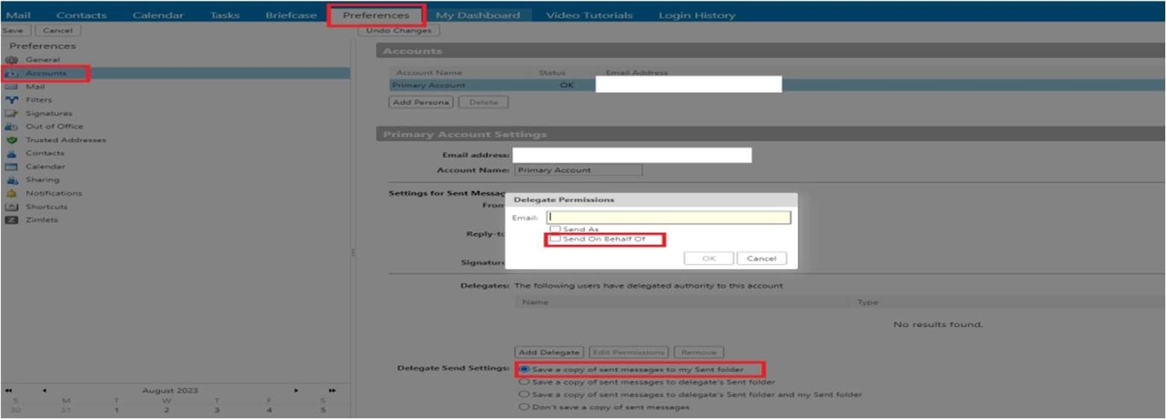

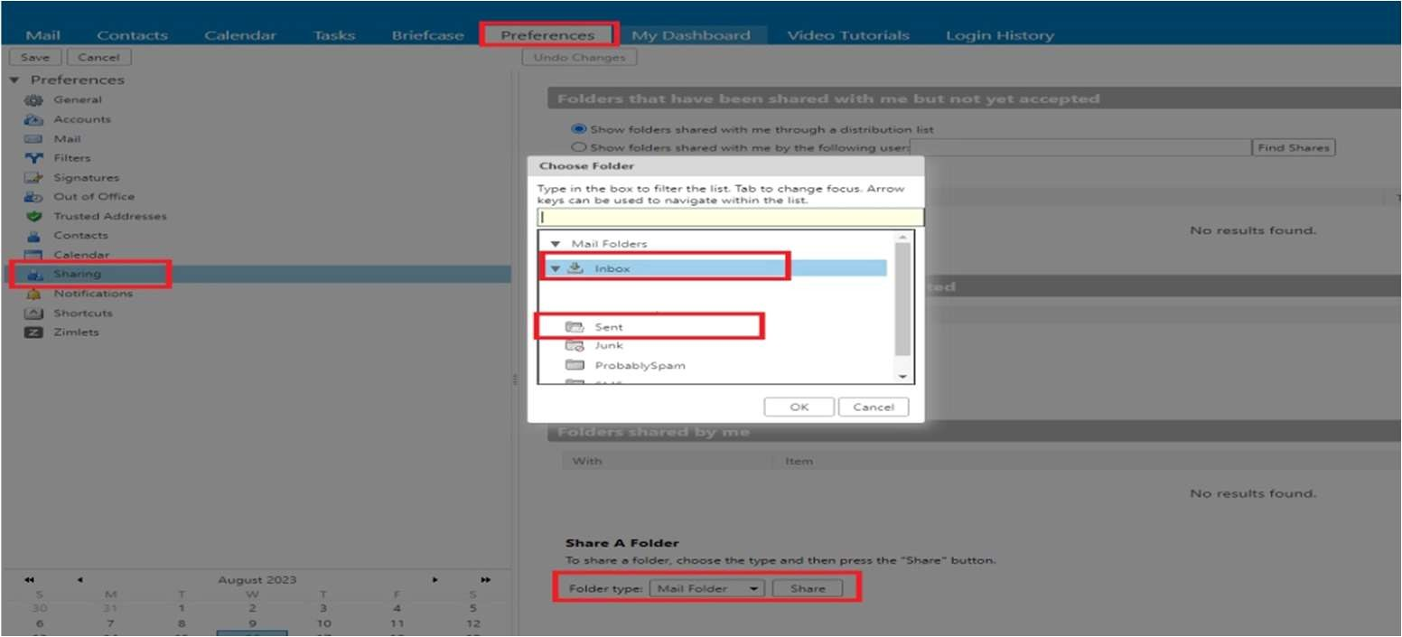

* + - 1. Till the time user id or login on Unified Portal is integrated with compliance e-Proceedings portal, e-notice intimating the date, time and mode of hearing is to be served to the employer through the dedicated official email-id of the officer conducting the proceedings to the email ids of the parties involved. The officer concerned shall ensure service of e-Notice containing details of virtual hearing specific to the said proceeding.
      2. Dealing Assistant concerned (or his/her link official) of the Compliance Circle shall host the virtual court hearing at the scheduled time and ensure that all parties are allowed into the court meeting with their audio and video functions active.
      3. All proceedings shall be recorded in the utility selected for virtual hearing and shall be retained till the upload of the daily order sheet of the next date of hearing. If no party raises objection to any part of the daily order sheet uploaded on the previous date of hearing, the recording shall not be retained further.
      4. The proceedings are to be drawn on the spot by the officer conducting the proceeding in the presence of the participating parties on the e-Proceedings portal directly using the screen share mode of the video conferencing utility which should be submitted immediately for the reference and use of the parties. Oral submissions made, including admission of liability by employer or consent of complainant to the assessment of dues and arguments put forth by the parties during the virtual court hearings should be recorded in daily order sheet.
      5. The daily order sheet so submitted may be downloaded by the parties for appending signature – digitally / physically – and emailing the same to the officer concerned within 24 hours. In case no reply is received, the daily order shall be deemed to have been accepted.
      6. If the employer needs to file documents / papers / statement in support of his/her case, the same shall be allowed to be filed by the employer from her/his registered email-id to the dedicated email-id of the officer conducting the proceeding. The documents should be in pdf format, properly indexed, and bear the digital / physical signature of the employer as mentioned in the Form 5A of the establishment. These should be provided to other parties to the case.
      7. If any employer or any other party to the dispute insists on filing submission / documents in hard copy through post or by delivery, the same may be allowed provided the same is submitted in digitally signed PDF format as well and properly indexed.
      8. As the next date and time of hearing shall be mentioned invariably in the daily order sheet itself, no separate adjournment notice is to be issued to the establishment / parties. Adjournments should not be allowed as a matter of routine and no adjournment should be allowed for more than 7 days in usual course.
      9. On conclusion of hearings, the following timeline should be observed for pronouncement of final order and follow up action:

|  |  |  |  |
| --- | --- | --- | --- |
| **S.No.** | **Issue** | **Timeline** | **Responsibility** |
| 1. | Pronouncement and Signing of Final Order | Within 15 working days from the  conclusion of  hearing(Tth day) | Officer conducting the proceeding |
| 2. | Upload of Signed Final Order on Portal | Tth day | SS & Dealing Assistant concerned of the  Compliance Circle |
| 3. | Dispatch of signed Final Order to Parties physically | T+1(Working Days) | SS & Dealing Assistant concerned of the  Compliance Circle |

* + - 1. Though the SS/Dealing Assistant of the Compliance Circle shall be uploading the final order, the ultimate responsibility of ensuring the same within the timeline above shall be of the officer conducting the proceeding.
      2. It should be ensured that the month wise details of dues are mentioned in the orders made under section 7A / 7B / 7C, so that difficulty in levying damages in lump sum assessment cases could be avoided. However, in case, it is not feasible to record dues on month-to-month basis, the reason thereof must be recorded in detail by the Officer conducting the proceeding in the final order.

## Dos & Don’ts of Inquiries

1. Inquiries under section 7A should only be initiated for the purposes provided in the statute i.e., for deciding disputes of applicability of the Act to the establishment or for determining dues payable under the provisions of the Act/Schemes. Grounds such as non-submission of returns, non-production of records, non-cooperation during inspection etc. are beyond the sweep of section 7A and should be dealt with through other mechanisms such as prosecution.
2. Inquiries under section 7A should only be initiated where there are sufficient and tenable reasons for doing so i.e., there is existence of *prima facie* case. The Officer initiating the

inquiry should record reasons in writing in the file of existence of a *prima facie* case based on evidence of default/evasion available on record or existence of an applicability dispute before initiating process under section 7A. Any inquiry or legal proceeding initiated without a prima facie case is of the nature of fishing and roving inquiry and the same is impermissible in law

1. A complaint is merely a source of information; at best, a lead. It does not constitute *prima facie* evidence. Any actionable complaint needs to be verified by the Enforcement Officer first and only on substantiation of the same on the basis of evidence collected, any inquiry under section 7A should be initiated. Initiating inquiries on the basis of complaints alone must be avoided as it is legally untenable.
2. Proximate nexus with the evidence and period of default available on record should be recorded in the file by the officer initiating the inquiry. Initiation of inquiries for prolonged periods such as more than 5 years should be avoided unless sufficient documents to do the assessment are available on record.
3. Scope and period of the inquiry should be decided beforehand and once finalized should be adhered to steadfastly. For any new period or issue, a separate notice must be issued. The records summoned from the employer should have reasonable linkage with the subject and period of determination. Summoning unrelated records for prolonged period amounts to conducting a fishing and roving inquiry which is not permissible in law.
4. Reason for initiation of inquiry must be recorded in writing in the Compliance file concerned and a copy of the documents relied upon and forming the basis of initiation of the inquiry must be supplied to the parties concerned along with the 7A summons.
5. The summons/notice initiating inquiry shall be assigned a computer- generated diary number from Compliance e-Proceedings portal invariably.

## Jurisdiction of Officers (Administrative Directions)

* + 1. Allocation of inquiries/proceedings to the officers is to be done randomly through e-Proceedings portal keeping in view the member-strength reckoned with reference to the subscriber-strength for the month immediately preceding the commencement of default (i.e., the latest information available on record)

|  |  |  |  |  |  |
| --- | --- | --- | --- | --- | --- |
| **Sl. No** | **Membership in the Establishments** | **DO where APFC is in- charge** | **RO / DO**  **where RPFC-II is in-**  **charge** | **In RO where RPFC-I is in- charge, and no RC-II is posted** | **In RO where RPFC-I is in-charge and where RPFC-II is/are also posted** |
| (1) | (2) | (3) | (4) | (5) | (6) |
| 1. | Establishments | APFC | APFC / | APFC | APFC |
|  | with |  | (RPFC II of |  |  |
|  | contributory |  | the DO |  |  |
|  | UANs up to |  | concerned) |  |  |
|  | 250 |  |  |  |  |
| 2. | Establishments | RPFC-I / | RPFC-II/ | RPFC-I/ Officer | RPFC-II |
|  | with | RPFC-II, as | Officer In- | In-Charge |  |
|  | contributory | the case | Charge |  |  |
|  | UANs from 251 | may be, in |  |  |  |
|  | to 1000 | accordance |  |  |  |
| 3. | Establishments | with Cols. | RPFC-II/ |  | RPFC-I/ Officer In- |
|  | with | (4), (5) & | Officer In- |  | Charge |
|  | contributory | (6) | Charge in |  |  |
|  | UANs from |  | case of RO; |  |  |
|  | 1001 onwards |  | RPFC-I of RO |  |  |
|  |  |  | in case of |  |  |
|  |  |  | DO |  |  |

***NB: In case an establishment files multiple ECRs for a wage-month, the sum of all contributory UANs is to be reckoned.***

* + 1. Once an inquiry is initiated u/s 7A/7B/7C on the prescribed criteria by jurisdictional officer, any fluctuation in the subscriber strength of the establishment in any wage month during the period of default for which inquiry is initiated shall not result in transfer of the case from officer of one level to another. Should a circumstance arise that the guidelines above are difficult to implement due to shortage of officers, the RPFC-in charge of the RO shall forward a self-contained proposal with

due justification to the ACC (Zone) for consideration. The ACC (Zone) shall be competent to decide on such proposals for deviation and decision of the ACC (Zone) on such proposal shall be conveyed within 3 days of its receipt, under intimation to the Head Office.

## Ex-parte Order

* + 1. Sub-sections 3A & 4 of section 7A deal with ex-parte orders i.e., orders passed in the absence of the employer/employee/any other party. Where the employer, employee or any other person required to attend the inquiry fails to attend the inquiry without assigning any valid reason or fails to produce any document or to file any report or return when called upon to do so, the officer conducting the inquiry may decide the applicability dispute or determine the amount due on the basis of evidence adduced during the inquiry and documents available on record.
    2. Confirmation of due service of notice/summons to the employer or any other person required to attend the inquiry or to produce any document or to file any report or return should be ensured before invoking the provision of section 7A(3A). In many cases it has been observed that the employer/complainant has not been aware of the proceeding being conducted. Most of the ex- parte orders are challenged on this very ground alone.
    3. Even in such cases where ex-parte orders are issued, the officer conducting the inquiry must pass a reasoned, fair, and just order. Many a times it is observed that proceedings are conducted in undue haste without providing reasonable opportunity to the employer/parties to contest the matter and/or arbitrary orders are passed leading to undue litigation and remanding back of cases/quashing of orders by higher judicial fora.
    4. It should also be kept in mind that power under section 7A(3A) to proceed with evidence and material available on record should be exercised only when powers under section 7A (2) have been exercised beforehand. The casefile must show that all possible efforts have been made to afford proper and sufficient opportunity to defend the matter by the employer and/or other parties involved.
    5. However, where an order u/s 7A (1) has been passed against an employer ex- parte, he may within three (3) months of communication of such order apply for setting it aside. If s/he satisfies the

officer that the show cause notice was not duly served or that he was prevented by any sufficient cause from appearing when the inquiry was held, the officer shall by an order set aside his earlier order and shall hear the matter *de-novo*.

* + 1. No order shall, however, be set aside merely on the ground that there has been an irregularity in the service of the show cause notice if the officer is satisfied that employer did have the notice of the date of hearing and had sufficient time to appear before the officer.
    2. Further, if any appeal has been preferred under the Act against the ex-parte order and the same has been disposed of, otherwise than on the ground of withdrawal of the same by the appellant, no application shall lie under section 7A (4) for setting aside the ex-parte order.
    3. Moreover, no order for setting aside shall be made on an application made under section 7A (4) unless notice of it has been served on the opposite party.

## Review u/s 7B

* + 1. In case of review applications filed against orders passed under section 7A (1), the powers under section 7B to review the orders shall be exercised by an officer only after obtaining the views of the officer next above in hierarchy. APFC of RO/DO shall obtain view of RPFC II (Compliance) of the RO/ RPFC I or Officer-in-Charge of the Regional Office (if RPFC II is not there in hierarchy). RPFC II of RO will likewise obtain the view of RPFC I of RO or Zonal ACC (in case the RO is headed by RPFC II or in case of ROs headed by RPFC I, no RPFC I is posted/available). RPFC I of RO shall obtain the view of Zonal ACC.
    2. The scope of review is extremely limited.
    3. Section 7B is a replica of Order XLVII Rule 1 of the Code of Civil Procedure,1908 and reads as under:

***7B. Review of orders passed under section 7A****.—(1) Any person aggrieved by an order made under sub-section (1) of section 7A, but from which no appeal has been preferred under this Act, and who, from the discovery of new and important matter or evidence which, after the exercise of due diligence*

*was not within his knowledge or could not be produced by him at the time when the order was made,*

*or on account of some mistake or error apparent on the face of the record or for any other sufficient reason, desires to obtain a review of such order may apply for a review of that order to the officer who passed the order:*

*Provided that such officer may also on his own motion review his order if he is satisfied that it is necessary so to do on any such ground.*

1. *Every application for review under sub-section (1) shall be filed in such form and manner and within such time as may be specified in the Scheme.*
2. *Where it appears to the officer receiving an application for review that there is no sufficient ground for a review, he shall reject the application.*
3. *Where the officer is of opinion that the application for review should be granted, he shall grant the same: Provided that,—*
   1. *no such application shall be granted without previous notice to all the parties before him to enable them to appear and be heard in support of the order in respect of which a review is applied for, and*
   2. *no such application shall be granted on the ground of discovery of new matter or evidence which the applicant alleges was not within his knowledge or could not be produced by him when the order was made, without proof of such allegation.*

*1. (5) No appeal shall lie against the order of the officer rejecting an application for review, but an appeal under this Act shall lie against an order passed under review as if the order passed under review were the original order passed by him under section 7A.*

* + 1. Hon’ble Calcutta High Court on a reading and comprehension of Supreme Court judgements on the issue of review has enumerated the principles that emerge therefrom:

1. The power of review is a limited power and would be governed by the principles of section 151 read with Order XLVII Rule 1 of the Code of Civil Procedure.
2. Firstly, a court can review its own judgement when there is a discovery of new and important matter or evidence that was in spite of exercise of due diligence not within the knowledge or could not be produced due to cogent reasons by the party seeking the review. Secondly, the Court may review its order or judgement on account of some mistake or error apparent on the face of the record. Thirdly, a residuary clause in Rule 1 of Order XLVII provides for a review ‘for

any other sufficient reason’. It is to be noted that the Apex Court on several occasions has held that the third condition ‘for any other sufficient reason’ has to be read within the four corners of the first two conditions.

1. An error which is not self-evident and has to be detected by a process of reasoning is not an error apparent on the face of the record.
2. A review petition has a limited purpose and cannot be allowed to be “an appeal in disguise.” There is a sharp distinction between an erroneous decision that can be only appealed against and an error apparent on the face of the record that is subject to review.

**[ The State of West Bengal vs Confederation of State Government Employees, 2019 (3) WBLR (Cal) 39]**

* + 1. It could, therefore, be seen that unless the employer comes up with irrefutable evidence about discovery of new facts or evidence which was not within his knowledge even after due diligence, the decision to re- open the issue should not be taken. The burden of proof is on the employer to bring sufficient proof, which despite his best efforts he could not produce at the time of inquiry or before the order was passed. In other words, a mere submission by the employer that he was not aware of the facts at the time of inquiry, or some vague submission that the material evidence or records was not available at the time of inquiry, would not be enough.
    2. Further, under section 7B, an application can be entertained only if the same is filed in form-9 within 45 days of passing of the order under section 7A. With a view to curb the indiscriminate use of section 7B, the following procedure should be followed in all cases.

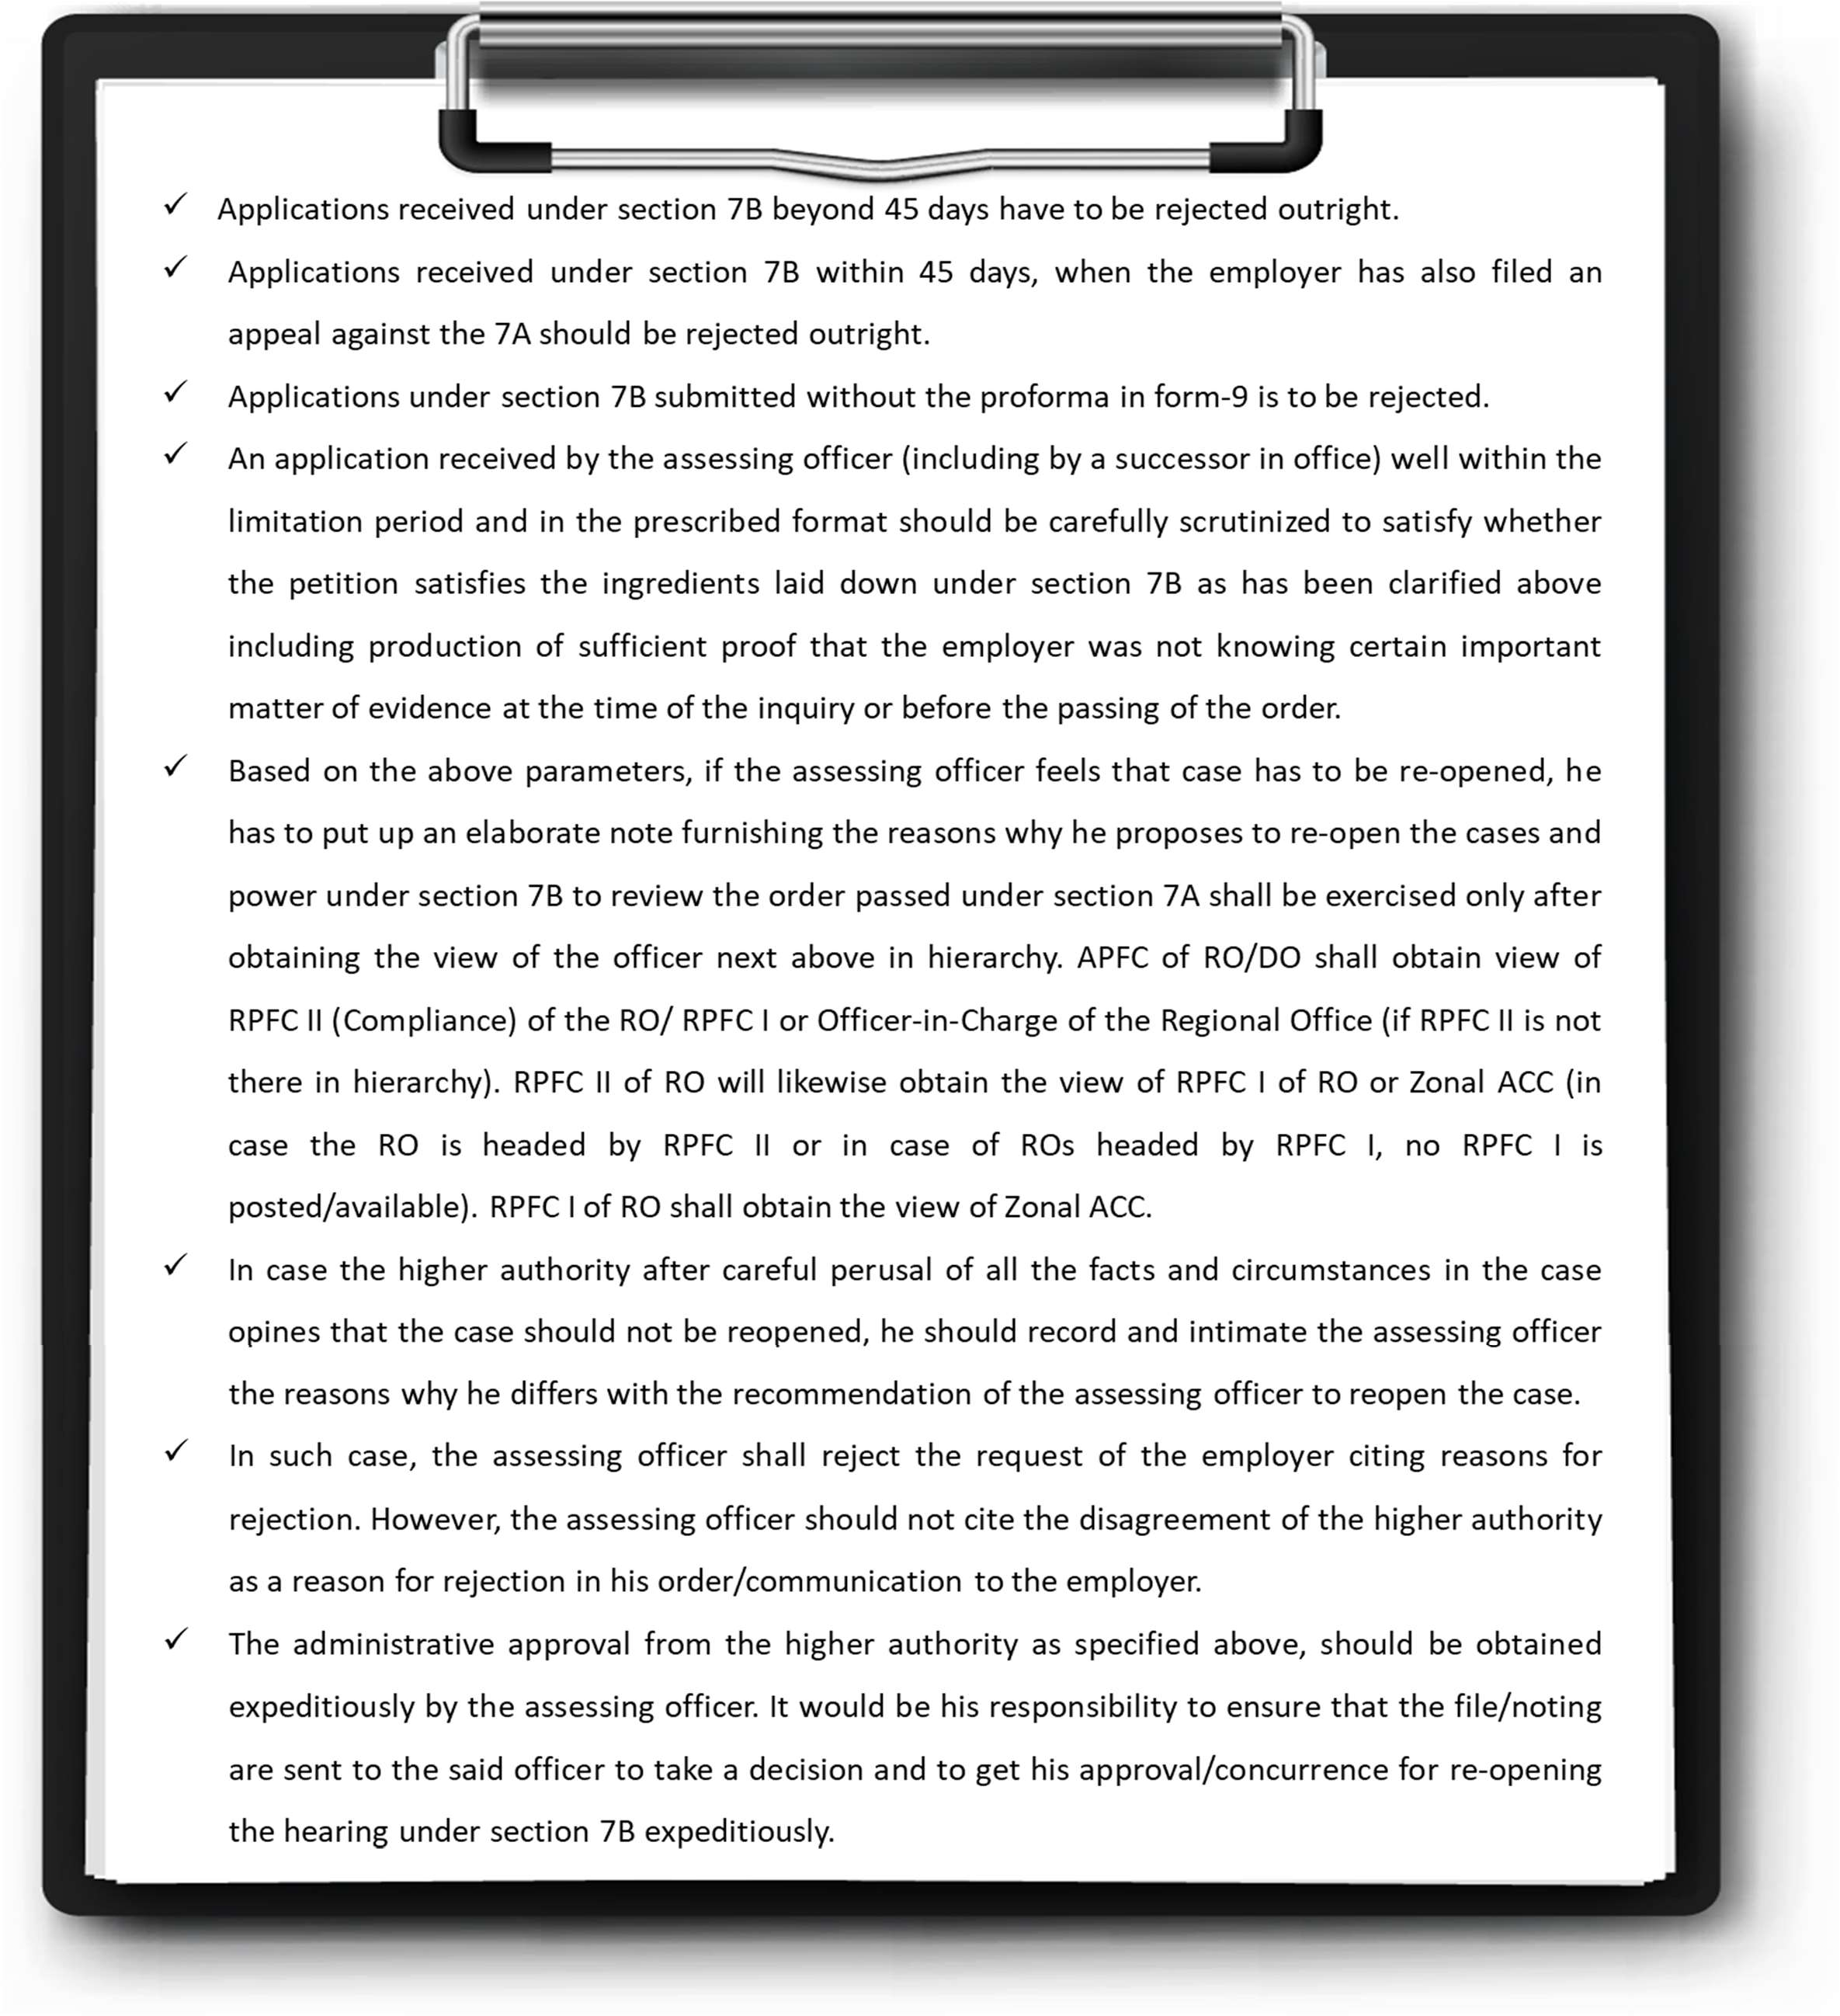

*Figure 6 : Processing of appliacations under section 7B*

* + 1. On the other hand, if the higher authority at the time of administrative scrutiny of the 7A order finds grounds for action under section 7B, he shall cause *suo moto* order for review under section 7B.

## Determination of Escaped Amount u/s 7C

* + 1. Section 7C deals with determination of escaped amount. Section 7C inquiry can only be done within a period of five (5) years from the date of communication of the order passed under 7A/7B.
    2. Where the officer has reason to believe that due to omission or failure on the part of employer to make any document or report available or to disclose, fully and truly, all material facts necessary for determining the correct amount due from the employer, any amount so due from the employer for any period has escaped his notice OR has, in consequence of information in his possession, reason to believe that any amount to be determined under section 7A or section 7B has escaped from determination for any period notwithstanding that there has been no omission or failure on the part of the employer, he may re-open the case and pass appropriate orders re- determining the amount due from the employer in accordance with the provisions of the Act.
    3. No such order under section 7C re-determining the amount due from the employer shall, however, be passed unless the employer is given reasonable opportunity of representing his case.
    4. HO directions are that without prejudice to the powers available to the officer who has passed the order under section 7A/7B, the officer at higher level who conducts supervisory test-check of the order may, if he/she so thinks, direct the officer concerned who has passed the order under section 7A/7B to exercise the powers under section 7C to determine the escaped amount or may do it himself/herself treating the order passed under section 7A as an order passed by himself/herself in exercise of their original jurisdiction. However, the power shall be exercised by one of the two only in each case.

## Handling of Cases remanded back by Courts

At times, 7A/7B/7C cases are remanded back by the Tribunal/High Courts for adjudication afresh. Many a times, these are time bound as well.

Therefore, HO directions are that hearing of remanded back cases are to be conducted by an officer administratively one level higher than the original adjudicating officer as detailed below:

|  |  |  |  |  |  |
| --- | --- | --- | --- | --- | --- |
| **S.**  **No** | **Authority having passed the Order u/s 7A/7B/7C** | **Authority to hear remanded back case** | | | |
|  | **If APFC in (2) is in-charge of DO** | **RO where RPFC- II is in-charge** | **In Region where RPFC-I is in- charge, and no RC-II is posted** | **In Region where RPFC-I is in-charge and where RPFC-II is/are also posted** |
| (1) | (2) | (3) | (4) | (5) | (6) |
| 1. | APFC | RPFC-II of  Region (including DO)  concerned | RPFC II | RPFC-I | RPFC-II |
| 2. | RPFC-II | NA | ACC-in-Charge  /RPFC-I of ZO to whom that case is assigned by  ACC-in-Charge | NA | RPFC-I |
| 3. | RPFC-I | NA | NA | ACC-in-Charge | ACC-in-Charge |

## Timeline

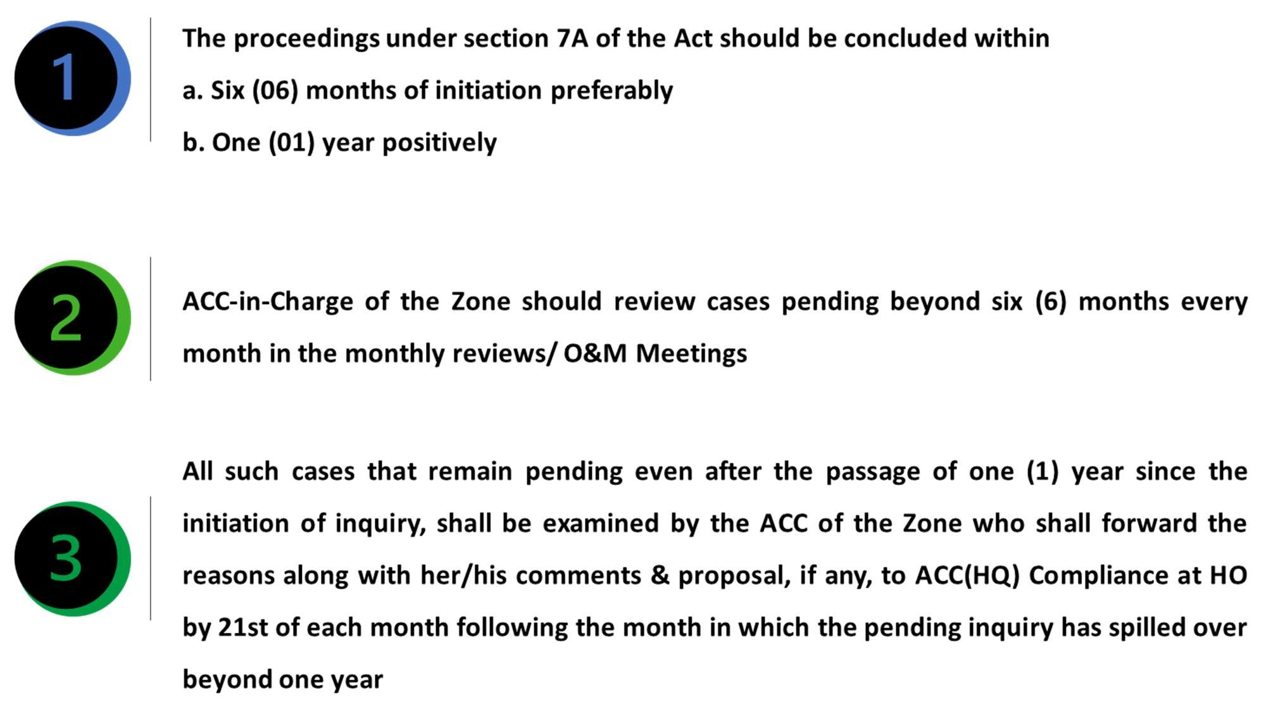

## Administrative scrutiny of Orders

* + 1. Supervisory test check or scrutiny of quasi-judicial orders is essential not only for capacity building of officers through regular guidance and feedback for improving the quality of orders but also to take prompt remedial measures in case of any omission, mistake, or irregularity. It is for this reason that it is imperative that a certain percentage of orders passed in inquiries and proceedings are subjected to supervisory test-check each month. The matrix for scrutiny is as under:

|  |  |  |  |  |
| --- | --- | --- | --- | --- |
| **S.**  **No** | **Authority having passed the Order u/s 7A/7B/7C** | **Officer to conduct Administrative scrutiny of Order** | | |
| **If APFC in (2) is in- charge of DO** | **RO where RPFC-II is in-charge** | **RO where RPFC-I is in-charge** |
| (1) | (2) | (3) | (4) | (5) |
| 1. | APFC | RPFC-II of RO (RPFC-I  in case no RPFC-II is posted in RO) | RPFC II | RPFC II (RPFC-I in  case no RPFC-II is posted in RO) |
| 2. | RPFC II | NA | ACC-in-Charge/RPFC-I of ZO to whom the  work is assigned | RPFC I |
| 3. | RPFC I | NA | NA | ACC-in-Charge |

* + 1. Administrative scrutiny of orders is to be carried out in the following cases every month:

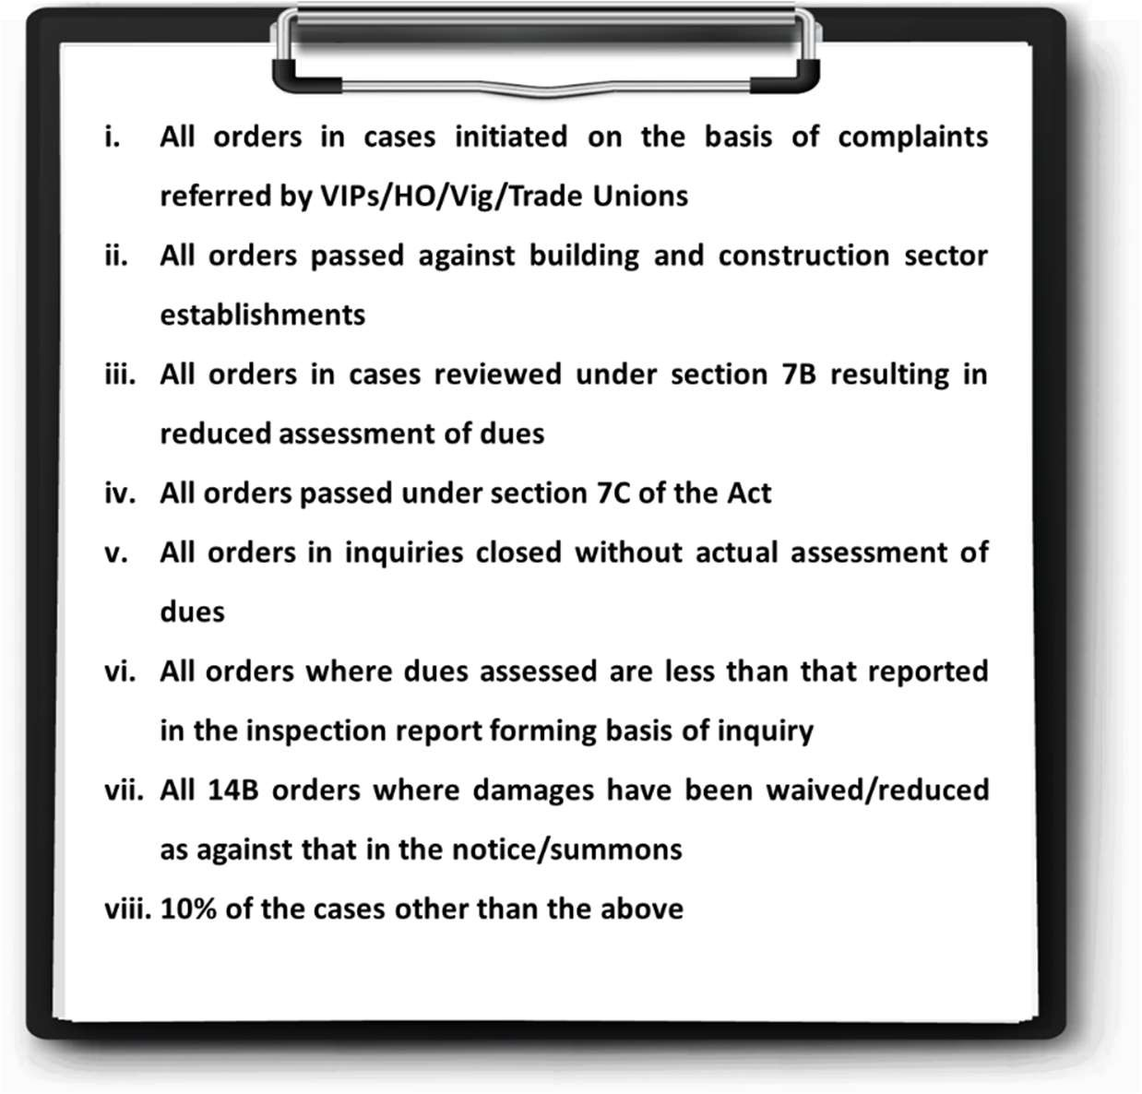

* + 1. Standard proforma for conducting the scrutiny is placed at **ST 8** for maintaining uniformity.
    2. Observations in the standard proforma shall be communicated to the officer concerned under intimation to next higher authority by 15th of the following month.
    3. During the scrutiny, wherever it is felt necessary to get the provisions of sections 7B/7C invoked, recommendation of the same is to be given immediately by the officer who has done the test- check/ scrutiny of the order. Ensuring action in this regard is also the responsibility of the officer concerned who has/should have done scrutiny of the order.
    4. During the scrutiny of orders passed under sections 7A/7B/7C, if it is observed that the decision is not in accordance with law, provisions of section 7 I should immediately be got invoked. The officer who has/should have done the scrutiny, is required to do the same. He shall get an appeal filed under section 7I against the said 7A/7B/7C order to protect the interest of the members/employees and /or the Organisation.
    5. Quarterly report shall be submitted by the Zonal Office in **ST 9** to Compliance Division (Vertical- IV.9) Head Office for the quarters ending June, September, December, and March of a year by the last working day of July, October, January, and April respectively.

## Indicative Structure of the order u/s 7A

* + 1. The order issued by the Assessing Officer should be a “speaking order”. Speaking order may be defined as an order which contains not only the conclusions and directions but also the reasons that have led to the conclusions. A speaking order speaks for itself and is considered the third pillar of natural justice. It builds up trust and confidence in the system and introduces fairness. The requirement of recording of reasons and communication thereof are considered as an integral part of the concept of just and fair administrative and judicial procedure and very important facet of natural justice. Failure to give reasons could lead to a very justifiable complaint that there was a breach of natural justice. Non- speaking order is illegal and against the principle of natural justice.
    2. Accordingly, to ensure that the orders do not suffer from any procedural infirmity, an indicative structure is provided below for guidance. It is made clear that the same is for guidance purpose

only and may be suitably amended and adapted keeping in view the needs and nature of the inquiry.

|  |  |
| --- | --- |
| **Sub-Head** | **Details** |
| **Basic Introduction of the**  **establishment** | This part should include basic introduction of the establishment  like Code No. etc., |
| **Background of the 7A** | This part would include citing of the inspection report/ other credible information being the basis of initiation of 7A inquiry, date of issue of summons and details of specific documents  summoned at the time of initiation of enquiry, if any. |
| **Appearance During the inquiry** | This part would include persons appearing on behalf of the establishment, appearing on behalf of the department and complainant, if any.  This part should also include only the specific dates of hearing. Thus, a bare perusal of the order would show the number of opportunities provided to the establishment as well as appearances during the enquiry. The service of summons to the establishment/complainant should be specifically recorded by the Assessing Officer. |
| **Records produced during the inquiry** | This part should list out in detail of records produced by the parties during the inquiry.  At the same time, if complete set of records are not produced by the establishment/complainant as summoned, a comparative summary of records not produced despite summons/notices can be mentioned in this part. |
| **Submission of the**  **establishment** | This part should elaborately record submission made by the  establishment during the inquiry. |
| **Submission of the**  **Complainant if any** | This part should include submission of the complainant, if any, in  detail |
| **Submission of DR** | This part would include details of viewpoint of the EPFO |

|  |  |
| --- | --- |
| **Sub-Head** | **Details** |
|  | represented through DR |
| **Deliberation recorded in the Daily Order Sheet** | Any specific event/issue recorded in the Daily Order Sheet or any serious development during the proceeding should find mention in this part, to highlight the intent of the establishment/complainant before any Appellate Forum/Court, if required.  However, normal routine developments like adjournments, next  date etc. should not be recorded in this part. |
| **Rule Provision** | This part of the order may specifically contain rule provisions as  appearing in Act/scheme. |
| **Analysis of facts/evidence vis- a vis rule provisions** | This part should contain the analysis of the facts and evidence produced before the assessing officer vis-a-vis relevant rule provision quoted in preceding paragraphs.  This part should deal with each, and every aspect of facts/evidence raised by either establishment/EO or complainant if any. The reasons for reaching a particular conclusion may be specifically highlighted in this part. The reasons for accepting/rejecting either establishment or DR or complainant’s submission may also find specific mention in this part of the order. |
| **Finding based upon analysis of facts/evidence *vis-a-vis* Rule provisions** | This part should record findings of the Assessing Officer with respect to each issue raised during the proceeding. Since the basis of arriving at any conclusion is already mentioned in the preceding part, repetition of the same may not be required at this  stage. |
| **Order** | This part would contain details of the final order i.e., either assessment or decision regarding applicability. In case of assessment, however, since the period of inquiry is specific, to avoid any kind of confusion, the amount determined must be  mentioned month-wise as |

|  |  |
| --- | --- |
| **Sub-Head** | **Details** |
|  | 1. Amount due for the period, 2. Amount already deposited and 3. Residual amount due from the establishment.   However, it is only the residual amount that should be reflected as Amount due from the establishment. |

* + 1. All orders passed under sections 7A/14B etc. are in public domain; required to be uploaded on e- Proceedings Portal. In addition, PDNASS is also compiling repository of selected orders which may be consulted for guidance purpose.

**\*\*\*CHAPTER END\*\*\***